HOME-BASED ON-THE-JOB-TRAINING IN SYSTEMS ANALYSIS AT PIXEL8 WEB SOLUTIONS AND CONSULTANCY INCORPORATED

An Internship/OJT Portfolio
presented to the faculty of the
Department of Computer Science and Technology
Faculty of Computing
Visayas State University
Visca, Baybay City, Leyte

In partial fulfillment
of the requirements for the degree of
BACHELOR OF SCIENCE IN COMPUTER SCIENCE

YSMAEL JOHN A. JAJALLA
AUGUST 2025

TABLE OF CONTENTS

TABLE OF CONTENTS iii
INTRODUCTION 4
1.1 Nature and Importance of the Internship/OJT 4
1.2 Objectives of the Internship/OJT 5
1.3 Time and Place of the Internship/OJT 6
WORK ACTIVITIES 8
2.1 Application and Acceptance of the Internship/OJT 8
2.2 Schedule of Activities and Works Done 10
DISCUSSION 12
3.1 Brief History 12
3.2 Vision of the Company/Agency 12
3.3 Mission of the Company/Agency 12
3.4 Organizational Structure of the Company/Agency 13
3.5 Services Offered/Provided by the Company/Agency 13
3.6 Company/Agency Policies and Incentives 14
3.7 Practical Experiences 15
3.7.1 Project Management 15
3.7.2 Benchmarking 16
3.7.3 Research Study Overview 16
3.7.4 Legal Framework 16
3.7.5 Pre-Development Documentation 17
3.7.6 Design and Prototyping 18
3.8 Problems Encountered in the Conduct of the Internship/OJT 19
SUMMARY AND RECOMMENDATIONS 21
4.1 Summary 21
4.2 Recommendations 22
REFERENCES 24

CHAPTER 1

INTRODUCTION

Nature and Importance of the Internship/OJT
On-the-Job training (OJT) is a necessary phase in professional development that allows students to involve themselves in the daily operations and processes of their chosen field. It provides an environment where they can interact with actual work process, technical and industry tools, and professionals while being supervised by mentors. Through OJT, students gain meaningful exposure to the realities of their field, helping them to develop both soft and technical skills (Nguyen, 2023; Loc et al., 2025).
As a Systems Analyst trainee at Pixel8 Web Solutions and Consultancy Inc., the student trainee was assigned in tasks that involved process analysis, design and prototyping, and improvement of business processes through technology driven solutions. The company operates to provide web design, graphic design, web application development, web development, information system, mobile development and Search Engine Optimization (SEO) for business, firms and government offices here and abroad.
The importance of system analysis in the computing world is its ability to ensure that technology solutions are not just functional but also aligned with the specific user requirements and organizational goals. In the field of computer science, systems analysis serves as a critical step in the Software Development Life Cycle, as it transforms conceptual ideas into practical systems. It usually involves examining business processes, identifying possible problems and determining the most effective solutions before the actual software development begins thus reducing the risk of errors and inefficiencies. By providing proper software documentation before the actual software development, systems analysts provide a structured and systematic approach to understand both technical and business needs which in turn helps bridge the gap between the developer’s side and the business side (MoldStud, 2024; Scaler, 2024). Without it, the risk of building wrong solution, wasting valuable resources such as time and money, and failing to meet user expectations would be significantly higher.
With the student trainees aim to enhance his skills and understanding in systems analysis and architecture, as well as to gain exposure to roles beyond programming, and to learn more knowledge in the computing world in alignment with the business side, he opted to join a company that provide their client with a good return of investment by improving their business thru efficient, fast, and effective software solutions at par with the international standard and reduce their costs by offering fair and reasonable rates.

Objectives of the Internship/OJT
The internship/OJT generally aims to equip students with practical industry experience in relation to the computer science field. This OJT has specific goals which are:
- to learn about actual industry practices and processes related to software development.
- to develop technical and soft skills that the industry is actively using.
- to experience new things aside from back-end programming

Time and Place of the Internship/OJT
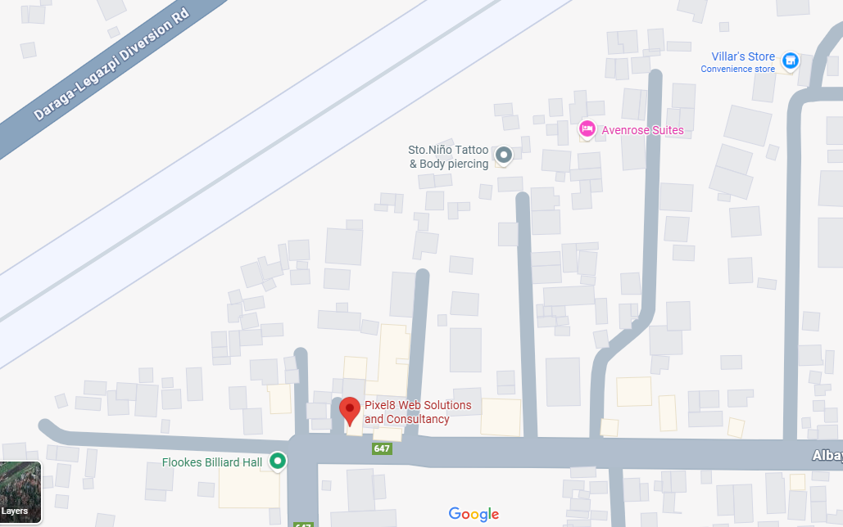
The OJT was conducted as a curriculum requirement requiring the student trainee to allocate 200 hours, but the company policy of Pixel8 requires the student to undergo training within 350 hours. The host training establishment is physically located at Barangay 40, Cruzada, Legazpi City, Province of Albay (Fig 1). As the location of the company is too far, the student trainee opted to work remotely (Fig 2).
Figure 1. Screenshot of Pixel8 Web Solutions and Consultancy Inc. on OpenStreetMaps

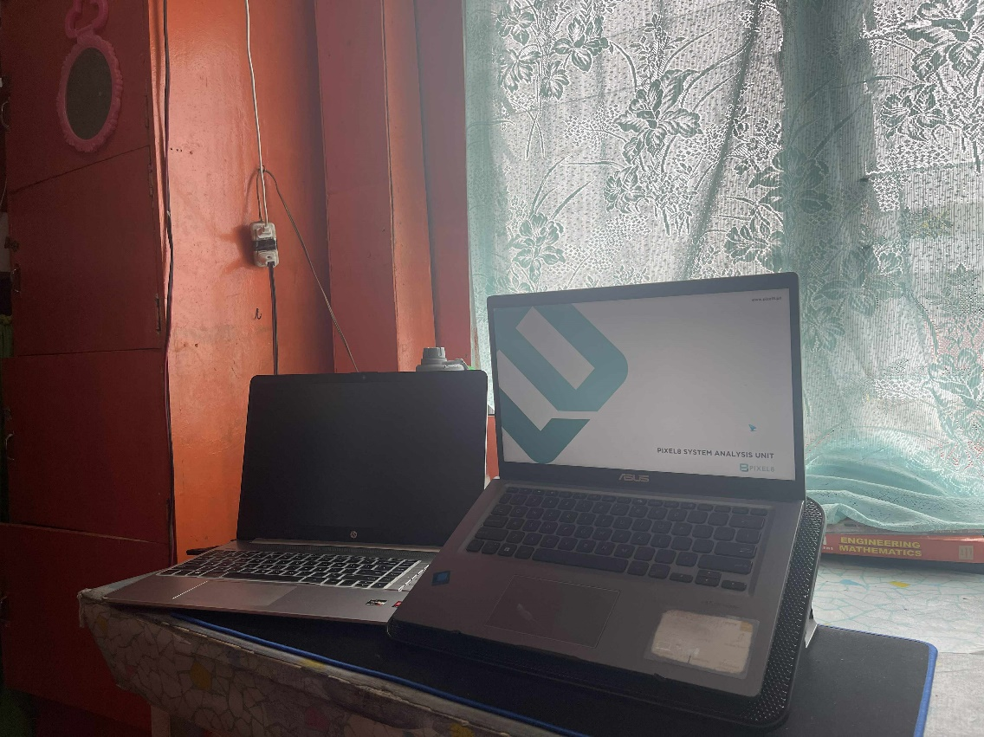
Figure 2: Remote work setup of the student intern

CHAPTER II

WORK ACTIVITIES

Application and Acceptance of the Internship/OJT
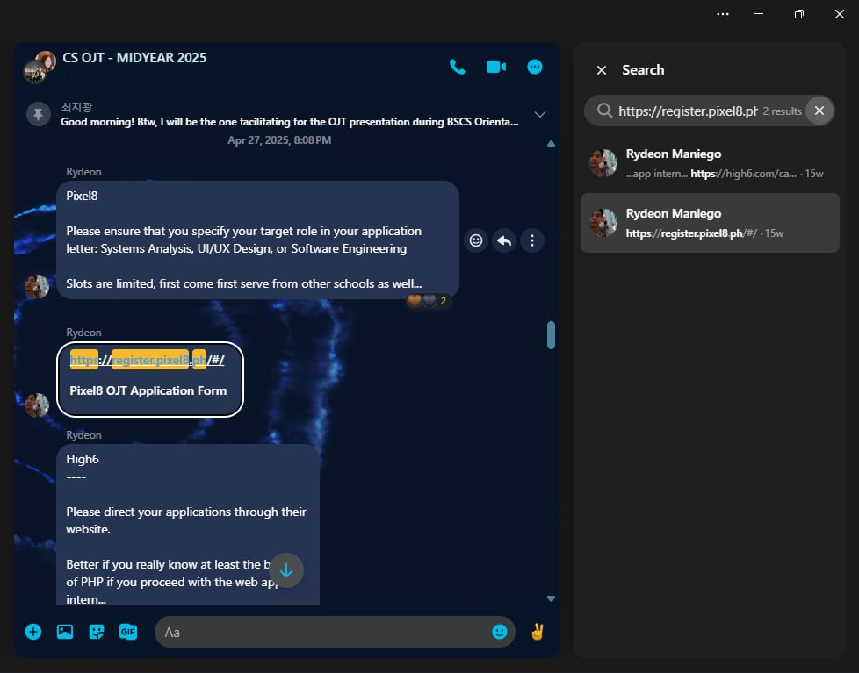
The Pixel8 Web Solutions and Consultancy Inc. is already an established partner HTE of the Department of Computer Science in Computer Science. On April 27, 2025, Mr. Rodney M. Maniego Jr. sent a message to our group chat that includes the link for the application for Pixel8 OJT (Fig. 3). They already have a website or landing page for interested or aspiring applicants (Fig. 4).
Figure 3: Screenshot of Mr. Maniegos message along with the application link

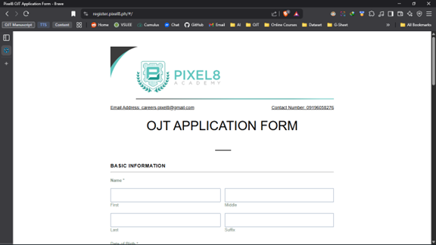
Figure 4: Screenshot of the Application Form
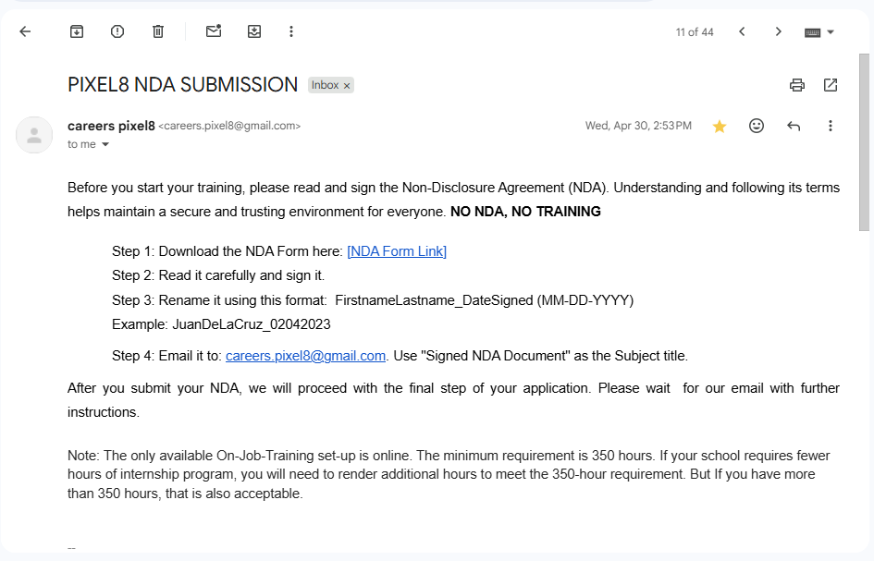
After filling out and submitting the application form on their website, the student trainee waited a few days for their HR team to reply. On April 30, 2025, they emailed the student trainee asking for his signature on the Non-Disclosure Agreement (Appendix ?) along with the submission instructions before proceeding to the final step of the application (Fig. 5). After a few days, their HR team replied to the student trainees NDA submission via email, with a welcome message and a link to join the Microsoft Teams group chat (Fig. 6).
Figure 5: Pixel8 NDA Submission Instructions

Figure 6: Acceptance Email from Pixel8

Schedule of Activities and Works Done
For the students to gain practical experience in working tasks in the industry, the company sets up a series of activities which the student trainee went through.
The first required activity the student trainee undertakes was the mandatory onboarding task set up by the company for the trainee to be familiar with the company’s design principles and regulations. The student trainee was able to familiarize himself with the company’s tools, which is Figma and all the protocols and procedures while working.
After completing the onboarding exercise, the student trainee attended the first official meeting with his co-trainee and supervisor for a briefing about the company procedures during the whole On-the-Job Training period. The supervisor then grouped the student trainees by three and was immediately given and briefed about their particular task. The student trainee with his groupmate was given a task to benchmark website, to create a research overview, and to build a system design and architecture for a system. Each task is associated with deadlines that is being provided by the supervisor in the project management software that the student trainees is using. When the projects reach the deadline, the supervisor will then assess the student trainees’ output and will give feedback via Microsoft Teams. Most of the time, the work revolves around revising and finalizing outputs. The student trainee must complete all tasks assigned to their team before officially ending the OJT program.
At the end of the OJT program, the student trainee processed all post-OJT related documents required by the department along with the offboarding procedures set by the company. The student trainee has his Monthly Attendance Sheets (Appendix ?), Weekly Activity Reports (Appendix ?), and HTE Evaluation Report (Appendix ?), signed by the supervisor. As an additional requirement by the company, the student trainee is required to fill-up a google form and film himself reflecting about the overall experience during the OJT period, as well as the problems encountered and recommendations to the company for them to improve the OJT experience of the future student trainee.

CHAPTER III

DISCUSSION

Brief History
Inspired by how a pixel is the building block of every image, Pixel8 Web Solutions and Consultancy has been a significant in the IT industry since 2016 that started in Software Development. The company has a dedicated team of over 20 skilled professionals that is on the mission to provide exceptional ICT solutions that empower business and individuals to succeed and is committed to supporting their clients in every step of the way. They take pride in taking in over 2000 OJTs that provides them with valuable learning experiences for students and with a growing family of over 140 customers. Nowadays, they are venturing into projects that allows integration of software with hardware.

Vision of the Company/Agency
Pixel8 Web Solutions and Consultancy Inc. vision is to empower communities and businesses through tailored technology solutions, bringing innovation, efficiency, and impact to every organization they work with. They also envision to provide convenience through technology by connecting the community to one network.

Mission of the Company/Agency
The mission of the company is to be a trusted leader in digital transformation for the public and private sector across the Philippines and beyond. They are also committed to develop integrated digital systems that will manage, automate and connect businesses processes.

Organizational Structure of the Company/Agency
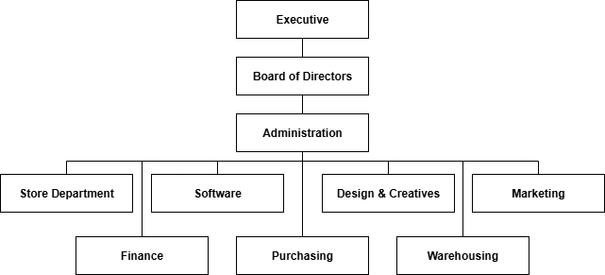
Pixel8 implements a hierarchical organizational setup. At the very top is where the Executive is seated. It is then followed by the Board of Directors. Belo of the Board of Directors is the Administration. And lastly, the very last are the Store Department, Finance, Purchasing, Software, Warehousing, Design and Creatives, and Marketing, which is managed by the Operations Manager under the Administration. The table (Fig. ?) below shows the overview of the hierarchical organizational structure of Pixel8 Web Solutions and Consultancy Inc.
Figure ?: Pixel8 Organizational Structure Overview

Services Offered/Provided by the Company/Agency
The company offers a lot of services and solutions. In Software Solutions, they offer Website Development, IGov Compliant Websites, Ecommerce Websites, Branding & Design, Mobile App Development and IT Consultancy. Their Software Products includes JuanHR (HRMIS), POSeidon (Point of Sale), VaxOut (Vaccine Registration), Queueing Management System and DMATS (Document Management and Tracking System). They also offer Network Infrastructure Solutions such as Network Structured Cabling, Fiber Optic Cabling, and Point to Point Antenna (Installation). Moreover, they offer Communication Solutions such as Public Address/Paging, VOIP, PABX and Security Solutions that includes Video Surveillance System, Fire Detection and Alarm System, Electric Fence, Automatic Gate, Access Control, and Metal Detectors. Their other solutions includes Solar Panels, Elevators, Home and Office ICT, Drones and Multimedia Equipment and Internet of Things (IoT).

Company/Agency Policies and Incentives
Before doing anything at all, the company requires the student trainee to sign a Non-Disclosure Agreement to ensure confidentiality of information and to prevent any unauthorized disclosure of the information and other data by the trainees.
The student trainees are required to do 350 hours of training during the whole OJT program under the Pixel8. The student trainee must work in an 8-hour shift per day between 8 o’clock in the morning until 5 o'clock in the afternoon with lunch break from 12:00 pm to 01:00 pm.
Microsoft teams and Mattermost is used in communication and online meetings. All trainees must attend every meeting where the supervisor is present. Moreover, during meetings, cameras should be always opened.
For Project Management, student trainees were instructed to create an account in OpenProject and use it to track the progress of their project. Student trainees must log their time spent on the specific project or task helping their respective supervisors to track the progress of the project and the time they spent on the project.

Practical Experiences
In accordance with the goals of the field practice, the student trainee was given and introduced to relevant tasks and experiences in the industry trends in information technology. These includes benchmarking websites, making a simple research overview and considering all the legal frameworks in relation to the software development, creating initial planning and documentation, and making a design and prototype of the system that we plan to implement.

Project Management
Project management is an important procedure that has evolved significantly with advancements in software tools and scientific scheduling techniques, enabling efficient planning, coordination, and control of complex projects across different fields, including software engineering. Effective project management ensures timely delivery, cost control, quality, and collaboration, contributing to overall project success (Kamdar et al., 2024; Ren & Li, 2023).
To fulfill the responsibilities of the training at Pixel8, the student trainee used the OpenProject software for project management. Through this platform, the trainee consistently recorded the hours spent working on the project and monitored deadlines to stay updated on the tasks assigned. This practice not only ensured accountability but also helped the student trainee remain organized and aligned with project goals.

Benchmarking
One of the most straightforward tasks assigned to the student trainee was benchmarking websites. As part of the training, the trainee was instructed to research websites with similar features to the software the company planned to develop. Each site was carefully examined and documented by manually noting its pages, components, fields, and forms. The trainee also performed manual testing to better understand the functionality of these platforms. To support the documentation, screenshots of the user flows and processes were organized in Figma, while a detailed record of all the procedures was compiled in a Word document

Research Study Overview
During the duration of the training, the student trainee also made a research overview that plays an important role in development process as it provides the foundation for informed decision-making. This document serves as the link between a strategic idea and its practical execution. This document is created to plan, define, and guide the development of a specific system that the company is planning to develop. This document also is a comprehensive plan that translates a business need into a detailed, actionable specification for a technology solution.

Legal Framework
While the Research Overview document outlined that “What” and “Why” questions, the Legal Framework document outlines the rules that the system must follow. This document is a legal and compliance reference guide. It’s a list of laws, executive orders, and government policies that regulates the system that the company wants to develop

Pre-Development Documentation
The pre-development documentation served as the primary focus of the student trainee’s work during the OJT. This phase consisted of three key Excel documents: the List of Acceptance Criteria (LAC), the Module Feature Description (MFD), and the Form Input Framework (FIF).
The LAC contained the conditions for software features and workflows. It was designed to ensure that every requirement was both testable and verifiable. Its purpose was to align expectations, guide development and testing, and minimize scope ambiguity.
The MFD outlined the modules and their corresponding features at the scope level. It functioned as a reference for understanding system functionality and how individual components fit together. This document supported communication of scope, delivery planning, effort estimation, and served as a shared blueprint for the team.
The FIF, meanwhile, specified form fields, data types, validations, dependencies, and UI input behaviors. It was an important reference for the UI/UX team in designing consistent forms and for the backend team in aligning data models. It is important as it standardize input, reducing rework, and ensuring both data integrity and compliance.
These documents translate business goals into structured, buildable technological specifications. They defined all the scope of the development phase of the software, and interfaces. During the duration of the training, the student trainee spent most of the time consulting the supervisor and revising those documents in accordance with the supervisors’ comments and recommendations. Constant revisions are important as system analysis a dynamic field, and staying updated is vital to remain relevant and effective.

Design and Prototyping
The design and prototyping stage in Figma was one of the key applications where the student trainee works. Using the List of Acceptance Criteria (LAC), Module Feature Description (MFD), and Form Input Framework (FIF) as references, the student trainee translated written specifications into visual and interactive representations. This stage was important in bridging the gap between system analysis and the actual software development implementation.
The LAC guided the design by ensuring that every feature represented in the prototype could be traced back to a verifiable requirement. This prevented unnecessary design elements and ensured alignment with functional expectations. The MFD provided a structural framework for organizing modules and features within the prototype, helping the trainee visualize system architecture and interaction between components. Finally, the FIF served as the foundation for form layouts, data inputs, validations, and field behaviors, ensuring that the prototype adhered to both usability standards and backend requirements.
Using Figma, the student trainee created wireframes, page layouts, and interactive flows that demonstrated how users would interact with the software. Screens and components were consistently aligned with the documented specifications and company trademark design and components, making the prototype both functional and user centered. Revisions were made regularly in consultation with the supervisor, ensuring that the evolving design reflected both technical requirements and practical usability considerations.
Overall, the prototyping process allowed the student trainee to transform abstract business and technological ideas and requirements into tangible, visual outputs. This not only improved communication between stakeholders but also reduced confusion before the actual software development phase begins, ensuring the accuracy of the pre-development documentation.

Problems Encountered in the Conduct of the Internship/OJT
During the OJT, the following are the problems encountered by the student trainee:
- Delayed giving of feedback. There were times when the supervisor could not provide feedback right away on the submitted tasks of the group or on the inquiry of the group about their assigned tasks. While the student trainee understands that everyone is busy, it did present a little bit of bottleneck that will be improved by providing a dedicated support system for student trainee.
- Difficulty in dividing equal tasks among group members. The way tasks were initially distributed felt inefficient. The student trainee did receive the bulk of the task as a group and be left amongst themselves to who would handle which parts. This process while encouraging teamwork can lead to some confusion and uneven workload, especially in team members who have different skill sets and knowledge levels. Some team members can be idle while others are doing a lot of work. The trainee who knew more could get to do more tasks compared to the other trainee.
- Communication challenges during virtual meetings. During the training, one challenge the student trainees frequently encountered was the background noise during online meetings with the supervisor, which often disrupted discussions and made it difficult to clearly understand the instructions from supervisor.

CHAPTER IV

SUMMARY AND RECOMMENDATIONS

Summary
The student trainee successfully completed a 350-hour home-based On-the-Job Training in Systems Analysis at Pixel8 Web Solutions and Inc. The program provided an immersive experience in the practical application of the Software Development Life Cycle (SDLC). Throughout the training, the student trainee was actively involved in a project focused on developing the pre-development document needed before the actual development of a system that the company aims to develop in the future requested by their client. Key responsibilities includes benchmarking existing similar platforms to identify industry standards and best practices, creating a research overview to define the projects purpose, goals, and scope, compiling legal frameworks documents to ensure the systems compliance with the Philippine regulations and laws, developing important pre-development documentation that includes List of Acceptance Criteria (LAC), Module Feature Description (MFD), and Form Input Framework (FIF), and translating these technical specifications into visual prototypes and design in Figma.
This hands-on work fulfilled the OJT’s primary objectives: to learn industry processes, develop technical and soft skills and gain experience in a role beyond programming. The student trainee effectively used tools such as OpenProject for project management during the whole duration of the OJT. The student trainee also effectively used tools such as Microsoft Teams for communication, and Figma for design. The experience provided the student trainee with the experience and profound knowledge and understanding of how abstract business needs are systematically translated detailed technology solutions, establishing the trainee’s skills in systems analysis and architecture design.

Recommendations
Based on the experiences and challenges that the student trainee faced during the whole duration of the OJT program in systems analysis at Pixel8 Web Solutions and Inc., the following recommendations are proposed to enhance the On-The-Job Training program of the company:
- Implementation of a structured approach for feedback system: To address delays in feedback, it is recommended to provide a dedicated time for trainee to ask questions and receive timely feedback, minimizing bottlenecks and keeping the project momentum.
- Implementation of Task Delegation Process for Groups: To ensure a more balanced workload, supervisors could break down large tasks into smaller, more defined sub-tasks before assigning them to a group. Assigning specific sub-tasks to individual student trainee based on their skills and knowledge level would prevent confusion, reduce idle time, and ensure all members contribute meaningfully to the project.
- Establish Clear Communication for Virtual Meetings: To lessen communication challenges caused by background noise, a simple set of meeting etiquette guidelines should be established. This could include requiring the use of noise cancelling headsets with microphones, requiring that participants mute themselves when not speaking, and encouraging the use of the chat feature for questions to avoid interrupting the speaker.

REFERENCES

Loc, T. B., Ngan, N. T., Linh, L. D., & Luan, N. T. (2025). On-The-Job Training: Enhance experience and increase success for the student community in Vietnam. SAGE Open, 15(1). https://doi.org/10.1177/21582440241311160
ERIC. (2022). The On-the-job Training (OJT) Pro Personal Development. https://files.eric.ed.gov/fulltext/ED654761.pdf
MoldStud. (2024, January 30). The Role of Systems Analysts in Software Development. https://moldstud.com/articles/p-the-role-of-systems-analysts-in-software-development-bridging-the-gap
Hammad, M. (2024, August 14). Role of System Analyst [Updated]. Scaler Blog. https://www.scaler.com/blog/role-of-system-analyst/
Kamdar, T. M., Desai, Y. S., Gautambhai, S. B., Kothari, K. A., Vasaikar, D. H., & Kiran, M. B. (2024). Significance of using software tools in project management review. Proceedings of the International Conference on Industrial Engineering and Operations Management, IEOM Society International.
Ren, Y., & Li, J. (2023). Research on software project schedule planning technology based on the integration of PERT and CPM. Procedia Computer Science, 228, 253–261. https://doi.org/10.1016/j.procs.2023.11.029
Pixel8 Web Solutions and Consultancy Inc. (2024, October 12). About - Pixel8 Web Solutions and Consultancy Inc. https://pixel8websolutions.com/about/
Merriam-Webster. (n.d.). Dictionary by Merriam-Webster. In Merriam-Webster. https://www.merriam-webster.com/

